The Tragedy of Macbeth
by William Shakespeare

Juan Felipe
1st Period

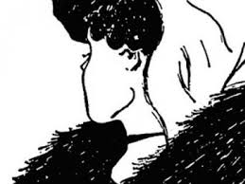

Act 1

Character Journal: Witches: Today is a nasty rainy day, perfect for us to start some trouble. Macbeth is returning for war and since he is such a great warrior, he will be a perfect victim for our senseless evil plan! I come Graymalkin!
Relevant Themes: The theme of things are not what they are is introduced in this passage. The witches express that what is good will be bad and what is bad will be good, setting up the theme for the remainder of the play.
Essential Quote: “Fair is foul and foul is fair!” (1.1.10)
Developing Characters: N/A
New Characters: Three craggy witches that speak paradoxically. they are evil as they serve demons.
Scene 1
Summary: Three Witches appear upon a deserted heath to discuss how they will meet with Macbeth after the war is over.

